**GUI In JAVA**

**Import library :**

import javax.swing.JOptionPane;

**Creating a J frame :**

import javax.swing.*;

import java.awt.*;

public class patient extends JFrame {

public static void main (String []args){

JFrame f =new JFrame();

f.setVisible(true);

f.setDefaultCloseOperation(JFrame.EXIT_ON_CLOSE);

} }

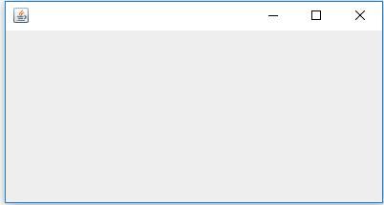

f.setDefaultCloseOperation(JFrame.EXIT_ON_CLOSE);

# USED TO TERMINATE PROGRAM ON CLOSING FRAME#

**Size of frame :**

f.setSize(700,500);

Means 700 height and 500 width.

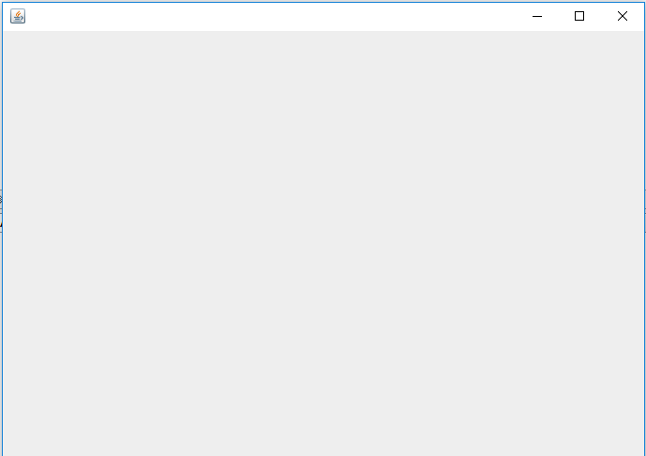

**Location of frame on screen :**

f.setLocation(400,100);

means 400 from left and 100 from top

**Title :**

f.setTitle(“Frame1”);



**Set icon image:**

ImageIcon im=new ImageIcon("111.jpg");

f.setIconImage(im.getImage());

**Set background image :**

Container c=f.getContentPane();

c.setBackground(Color.red);

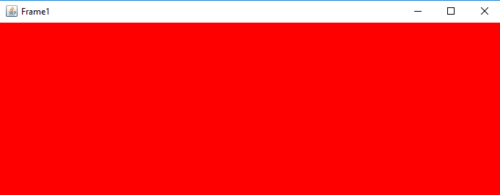

**For String input :**

String input1=JOptionPane.showInputDialog("Enter first number");

**For converting String to int :**

int num1string=Integer.parseInt(input1);

**Displaying int in a message box :**

JOptionPane.showMessageDialog(null,"Answer is"+input1);

